RACK INSTALLATION

1500/2000VA(optional)
SN | Description | Color | Sketch Map
① | RACK PLATE(FRONT) | BLACK | 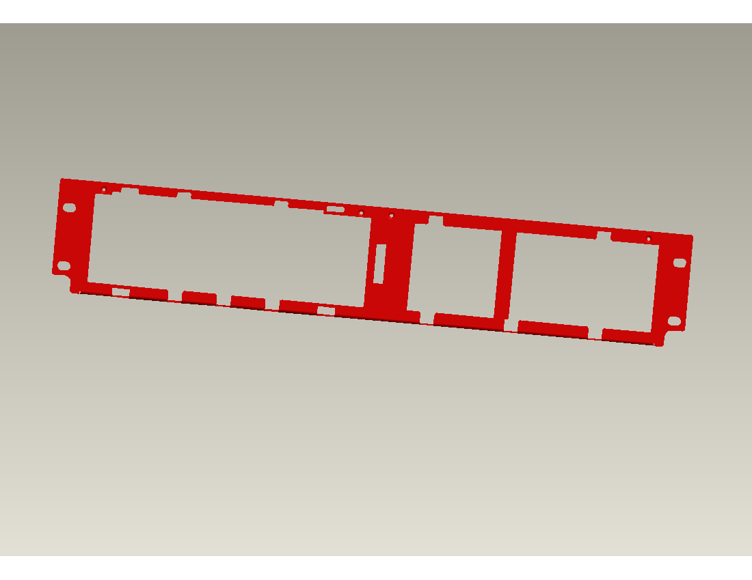
② | RACK PLATE(BACK) | BLACK | 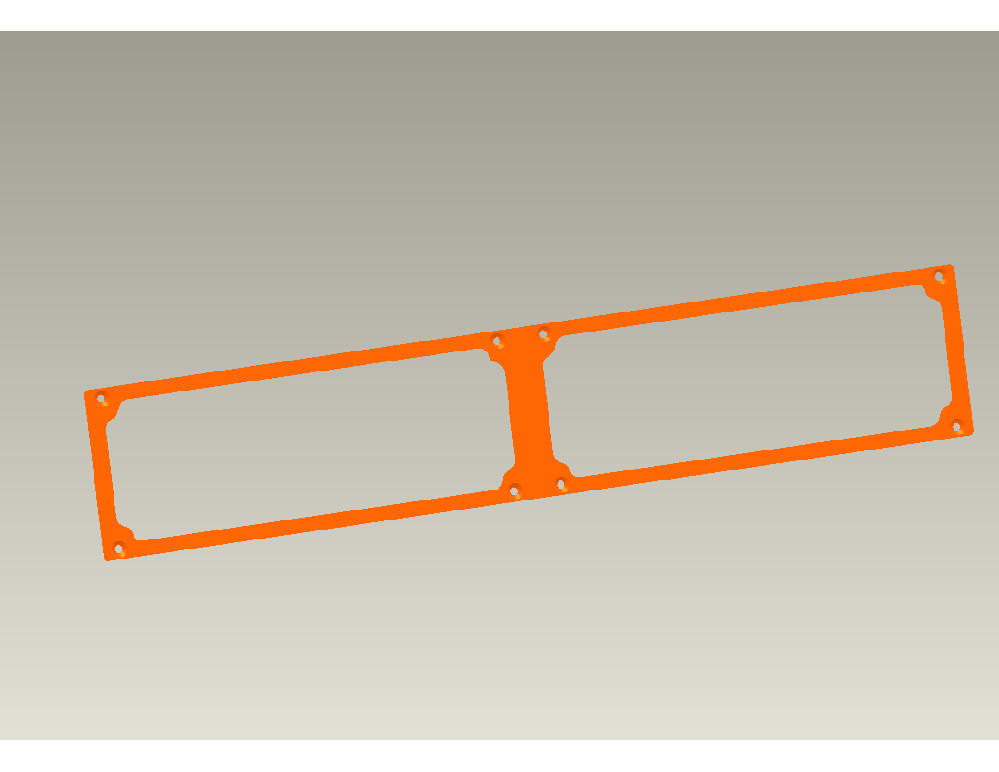
③ | SCREW M3*8 | nickel chrome steel

- HOST and EBM integrate into a rack form

- Place the UPS on a flat and in a clean place that the front side of the UPS is facing to you.

- Disconnect the cable from the Host and EBM.

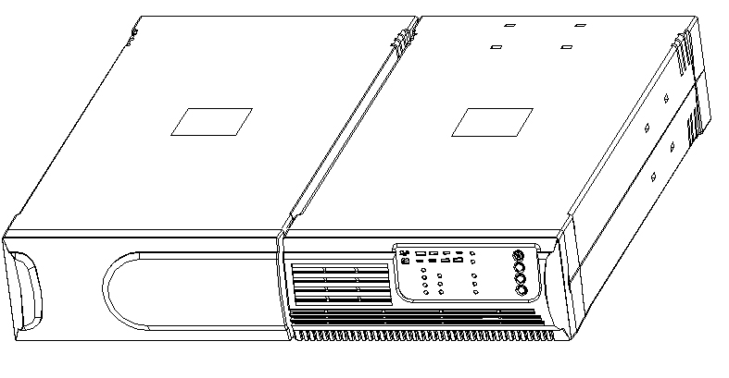

HOST and the EBM are disconnected

- Remove the Host and EBM cover by unscrewing and pulling them toward the direction shown as below.
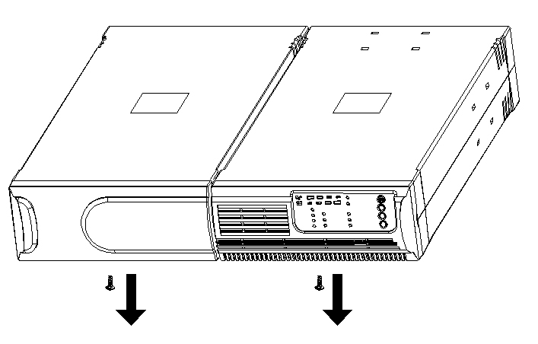

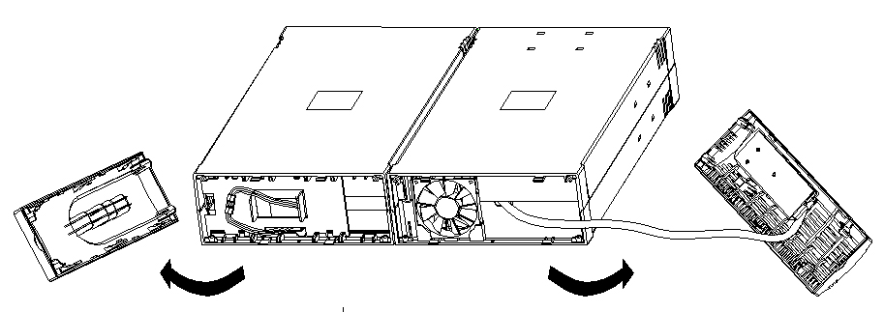

- Align the mounting bracket ① with the screw holes on the each side of Host and EBM and secure with the supplied screws ③(9ea).
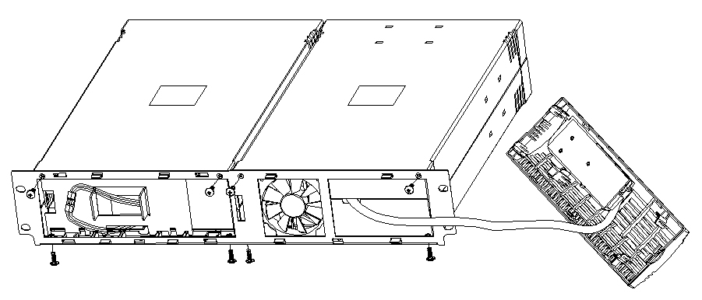
1
3
- Reinstall the Host and EBM cover.

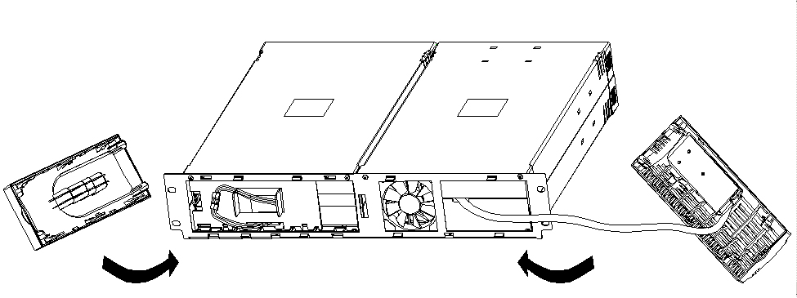

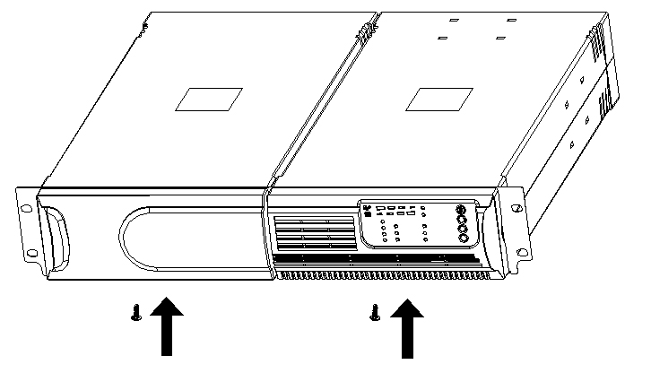

6. Setup rack-mount for front side is completed

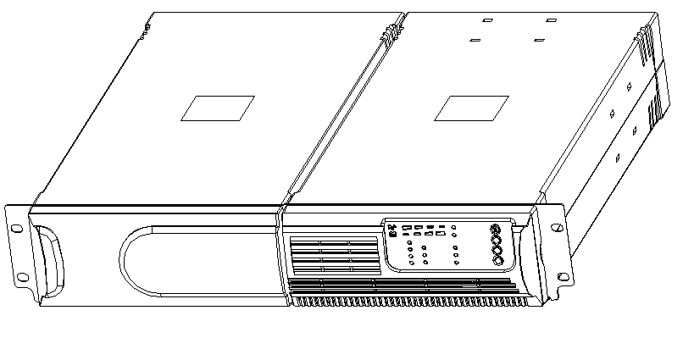

7. Align two small mounting brackets ② at the rear of Host and EBM and secure with the supplied screws ③(8ea). Install Output receptacles at the rear panel of the Host.

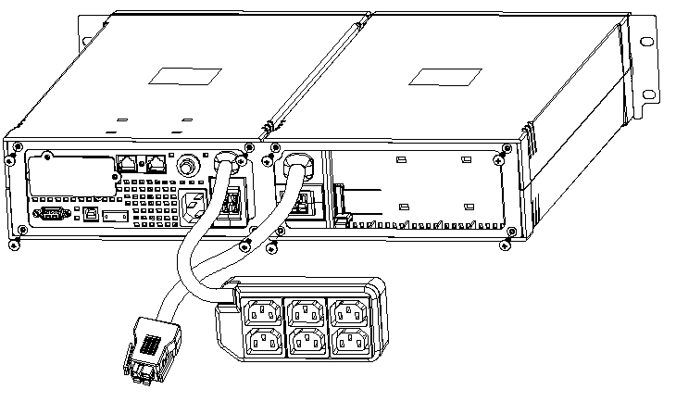
2
3

8. Setup rack-mount is completed and to connect the UPS

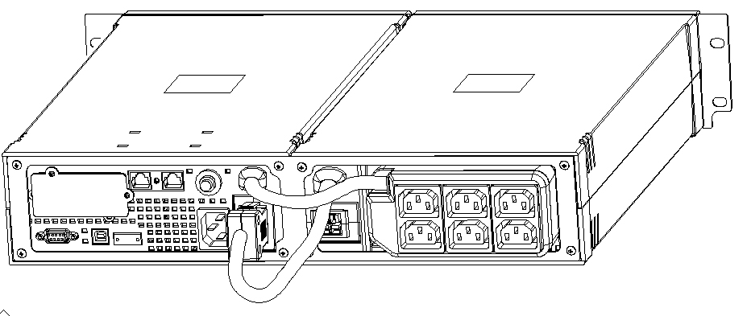

- EBM and EBM integrate a rack form
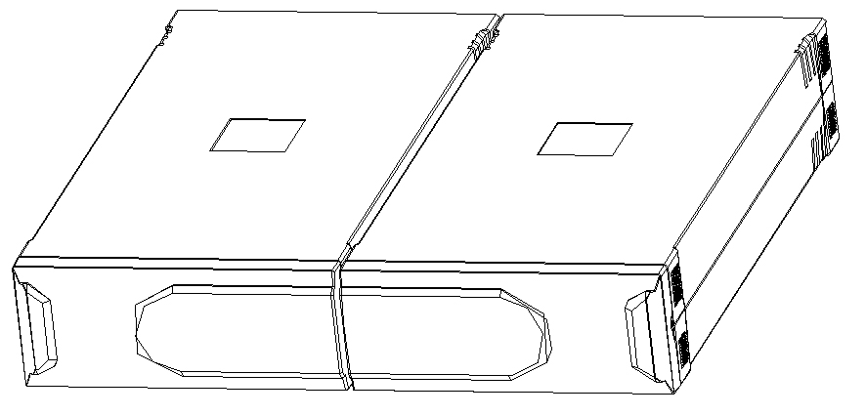
SLIDE INSTALLATION
1500/2000VA(optional)
SN | Description | Color | Sketch Map
① | SLIDE LEFT | ZN | 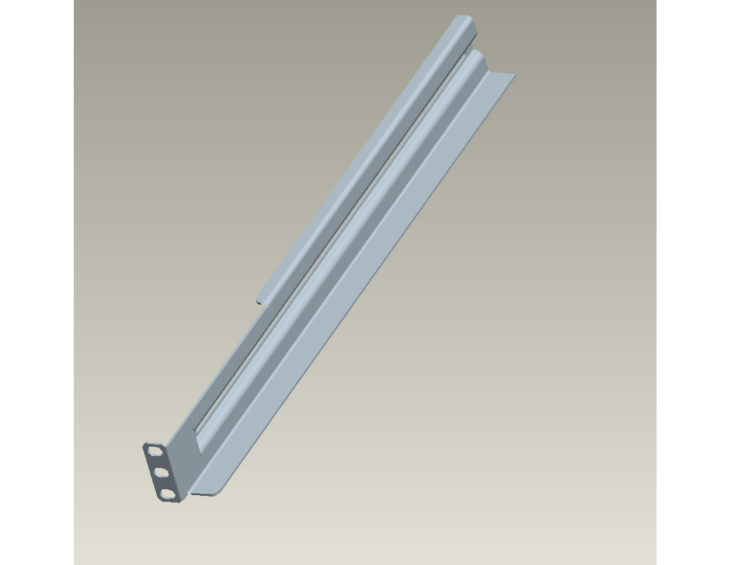
② | SLIDE RIGHT | ZN | 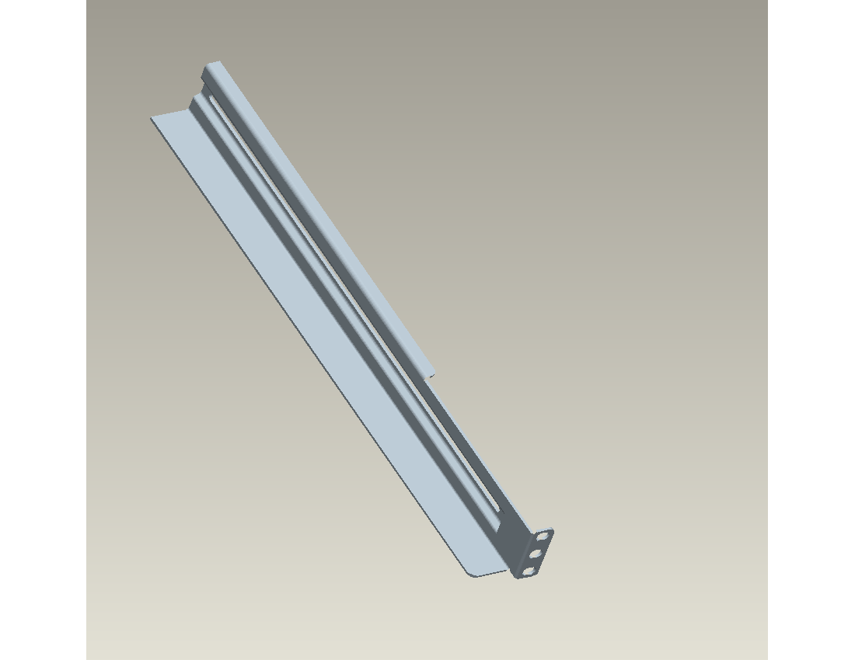
③ | SLIDE REAR | ZN | 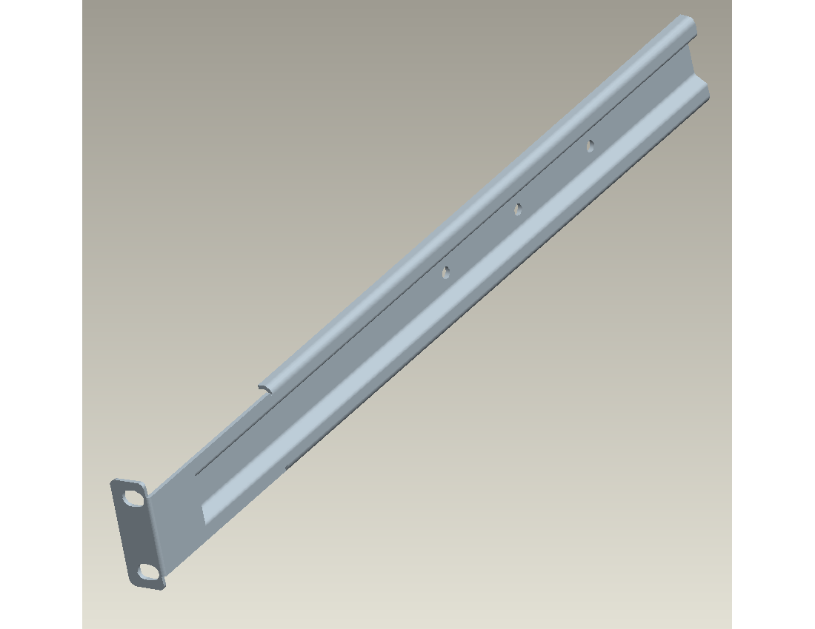
④ | SCREW&WASHER M4*8L ROUND CROSS TEETH NI | nickel chrome steel
⑤ | SCREW M6*16 ROUND CROSS NI | nickel chrome steel | 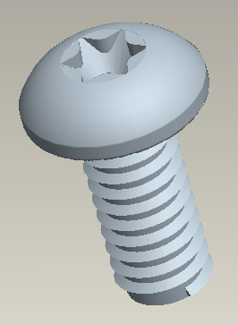

1. Compose HOST and EBM into a rack assembly.

2. Align rack-mounting rails, and fixed them with screws ④ (6EA) provided. In order that rack-mounting rails can glide, the two screws don’t lock close.
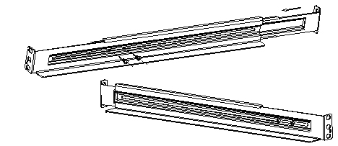
1
4

3
2

3. First align the slide-rail on both sides of rack by the screw holes, and lock a screw ⑤(2ea) in the downside hole of both sides at the front of the rack.
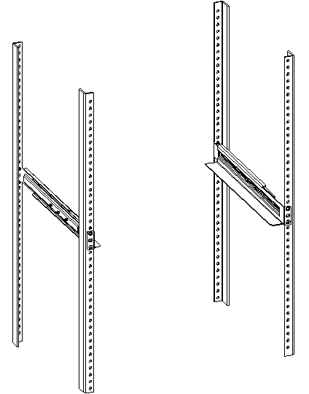
5
3. Lock screws ⑤(4ea) in four holes on both sides at the rear of the rack.
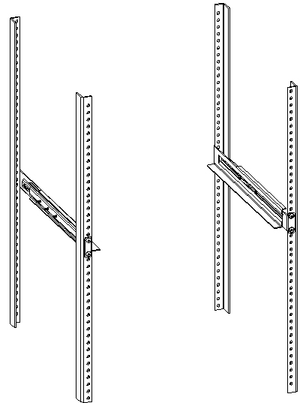
5

4. Insert UPS into the slide-rail and lock it with screws ⑤(4ea) in the rack enclosure.
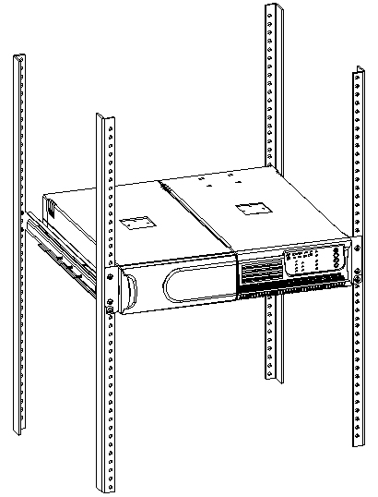
5

