USER MANUAL  Direct Power 400/600/1000  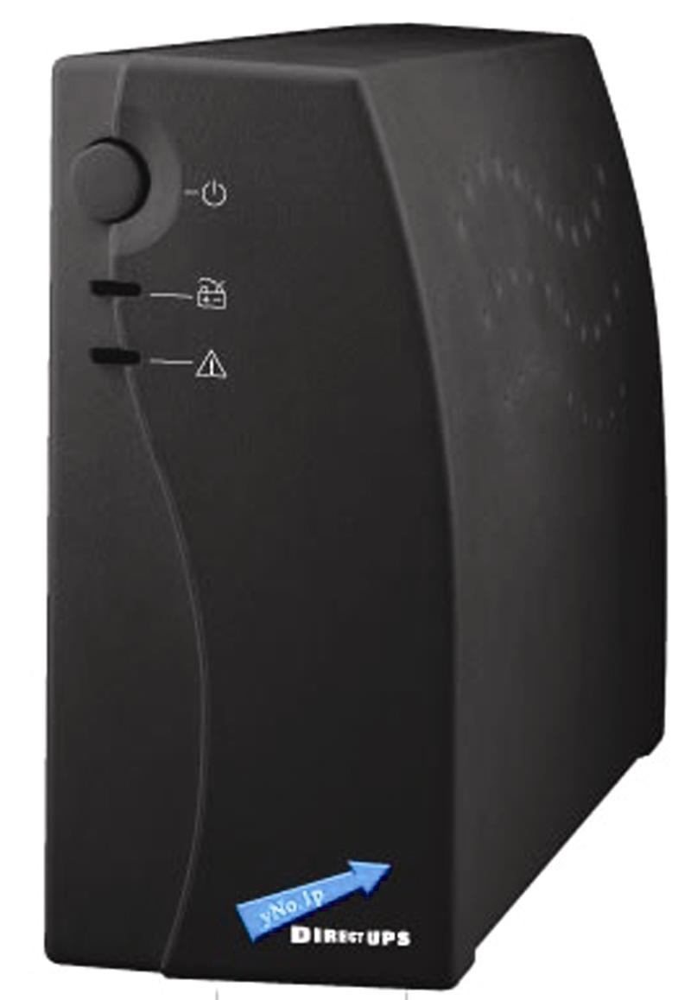  Uninterruptible Power System  20-3MAXPO0180 | IMPORTANT SAFETY INSTRUCTIONS  SAVE THESE INSTRUCTIONS  This manual contains important instructions for models Direct Power 400/600/1000 that should be followed during installation and maintenance of the UPS and batteries.  Safety – CAUTION!  - This product is specially designed for PCs and it is not recommended for use in any life-supporting system and other specific important equipment.  - This equipment can be operated by any individual with no previous training.  - Do not plug household appliances such as hair dryers to UPS receptacles.  - This unit intended for installation in a controlled environment (temperature controlled, indoor area free of conductive contaminants). Avoid installing the UPS in locations where there is standing or running water, or excessive humidity.  - CAUTION: Risk of electric shock, do not remove cover. No user serviceable parts inside. Refer servicing to qualified service personnel.  The utility power outlet shall be near the equipment and easily accessible. To isolate UPS from AC input, remove the plug from the utility power outlet.  - If UPS is to be stored for a long time, it is recommended to recharge the batteries (by connecting the utility power to UPS, switch “ON”), once a month for 24 hours to avoid a full battery discharge.  Please do not use the UPS in excess of the rated load capacity.  - The UPS contains one/two large-capacity batteries. So the shell shall not be opened, otherwise such dangers as electric shock will be caused. If any internal overhaul or replacement of the battery is required, please contact the distributor.
- The internal short circuiting of the UPS will lead to dangers such as electric shock or fire, therefore, no water containers (such as a water glass) shall be placed on the top of the UPS so as to avoid such dangers as electric shock.  - Do not dispose of battery or batteries in a fire. The battery may explode.  - Do not open or mutilate the battery or batteries. Released electrolyte is harmful to the skin and eyes. It may be toxic.  - Φ on the rating label stands for phase symbol.  - A battery can present a risk of electrical shock and high short circuit current. The following precautions should be observed when working on batteries :  - Remove watches, rings, or other metal objects from the hand.  - Use tools with insulated handles.  - Servicing of batteries should be performed or supervised by personnel knowledgeable of batteries and the required precautions. Keep unauthorized personnel away from batteries.  - When replacing batteries, replace with the same type and number of the sealed lead-acid batteries.  - The maximum ambient temperature rating is 40℃.  - This pluggable type A equipment with battery already installed by the supplier is operator installable and may be operated by laymen.  - During the installation of this equipment it should be assured that the sum of the leakage currents of the UPS and the connected loads does not exceed 3.5mA.  - Attention, hazardous through electric shock. Also with disconnection of this unit from the mains, hazardous voltage still may be accessible through supply from battery. The battery supply should be therefore disconnected in the plus and minus pole of the battery when maintenance or service work inside the UPS is necessary.  - The mains socket outlet that supplies the UPS shall be installed near the UPS and shall be easily accessible. | - In case smoke is found coming out from the device, please cut off the power supply quickly and contact the distributor.  - Do not keep or use this product in any of the following environments:  - Any area with combustible gas, corrosive substance or heavy dust.  - Any area with extraordinarily high or low temperature (above 40˚C or below 0˚C) and humidity of more than 90%.  - Any area exposed to direct sunshine or near any heating apparatus.  - Any area with serious vibrations.  - Outdoor.  - In the event that there is fire occurring in the vicinity, please use dry-power extinguishers. The use of liquid extinguishers may give rise to the danger of electric shock.  - System Description  Front panel:  Power Switch  - UPS status Indicator –  AC Mode: Green lighting  Battery Mode: Green flashing  3. Fault LED: Red flashing  Back Panel:  - Output receptacles  - Fuse  - AC Input  - Coaxial Connector (Option)  - phone system, computer, monitor against surges and spikesSurge Protection (Option)
- Installation and operation  - Inspection  Remove the UPS from its packaging and inspect it for damage that may have occurred during shipping. If any damage is discovered, repack the unit and return it to the place of purchase.  - Charging  This unit is shipped from the factory with its internal battery fully charged, however, some charge may be lost during shipping and the battery should be recharged prior to use. Plug the unit into an appropriate power supply and allow the UPS to charge fully by leaving it plugged in for at least 10 hours with no load (no electrical devices such as computers, monitors, etc.) connected.  - Placement  Install the UPS unit in any protected environment that provides adequate airflow around the unit, and is free from excessive dust, corrosive fumes and conductive contaminants. Do not operate your UPS in an environment where the ambient temperature or humidity is high.   |  | - Computer Connection  Plug the UPS into a 2-pole, 3-wire grounded receptacle. Then connect one computer-related device into each of the power receptacles supplied on the back of the UPS.  - phone system, computer, monitor against surges and spikes Connection (Option)  Plug incoming Internet line into the “In” socket at the back of the UPS. Use one more Internet line cable and plug one end of the Internet line cable to the “Out” socket at the back of the UPS. Plug the other end to the modem input socket as shown.  Incoming Internet Line  - Turn On/Off  Press the switch of the UPS continuously for 1 second and the UPS turns into its normal state (the green light is on and the beeper is off) after it performs a self-diagnosis (the beeper and the red and green indicator lights are on) for several seconds. At this time, user may turn on the PC and other loads. Press the switch of the UPS continuously for 1 second to turn off the UPS.  Note: 1. For the convenience of maintenance, please turn on the UPS first before turning on the PC and the other loads, and turn off the UPS after the loads are turned off.  2. At ordinary times, we recommend to remain the UPS on with the battery charging (even if the loads are turned off), which is benefit to the maintenance of the battery.
3. Trouble Shooting  If any abnormal situations occur that are not listed above, please call service people immediately. |  | 4. Specification
  Symptom | Possible Cause | Remedy
  No LED display on the front panel. | 1. Battery weak | 1. Re-charge battery up to 8 hours.
  No LED display on the front panel. | 2. Battery defect. | 2. Replace with the same type of battery.
  No LED display on the front panel. | 3. Power switch is not pressed. | 3. Press power switch again.
  No LED display on the front panel. | 4. Battery connector loosed | 4. Check the internal battery connection
  When power failure, backup time is short. | 1. Overload of the UPS. | 1. Remove some non-critical load.
  When power failure, backup time is short. | 2. Battery voltage is too low. | 2. Charge battery 8 hours or more.
  When power failure, backup time is short. | 3. Battery defect due to high temperature operation environment, or improper operation to battery. | 3. Replace with the same type of battery.
  Mains normal but LED is flashing. | 1. Fuse is blown. | 1. Replace the same type of fuse.
  Mains normal but LED is flashing. | 2. Power cord is loose. | 2. Reconnect the power cord properly.
  MODEL |  | DP 400 | DP 600 | DP 1000
  CAPACITY | VA/W | 400VA/200W | 600VA/300W | 1000VA/600W
  INPUT | Voltage | 110/120VAC or 220/230/240VAC
   | Voltage Range | 90-145VAC / 170-270VAC
  OUTPUT | Voltage | 110/120VAC or 220/230/240VAC
   | Voltage Regulation  (Batt. Mode) | ±10%
   | Frequency | 50Hz or 60Hz
   | Frequency Regulation (Batt. Mode) | +/-1 Hz
   | Output Waveform  (Batt. Mode) | Modified Sinewave
  BATTERY | Battery Type & Number | 12V/4.5Ah x 1pc | 12V/7.2AH x 1pc | 12V/7.2AH x 2pc
   | Back up Time (at a PC load with 15" monitor) | 5 minutes | 8 minutes | 20 minutes
   | Recharge Time | 10 hours to 90% after complete discharge
  TRANSFER TIME | Typical | 2-6ms
  INDICATOR | AC Mode | Green LED lighting
  INDICATOR | Battery Mode | Green LED flashing every 4 seconds
  INDICATOR | Low Battery at Battery Mode | Green LED flashing every second
  INDICATOR | Fault | Red LED lighting
  INDICATOR | Battery Weak at AC Mode | Red LED flashing every 2 seconds for 30 seconds
  INDICATOR | Battery Fault at AC Mode | Red LED flashing three times every 2 seconds
  AUDIBLE ALARM | Battery Mode | Sounding every 4 seconds
  AUDIBLE ALARM | Low Battery at Battery Mode | Sounding every second
  AUDIBLE ALARM | Fault | Continuously sounding
  AUDIBLE ALARM | Battery Charging at AC Mode | Sounding every 2 seconds for 30 seconds
  AUDIBLE ALARM | Battery Weak at AC Mode | Sounding three times every 2 seconds
  PROTECTION | Full Protection | Discharge, overcharge
  PHYSICAL | Dimension, DXWXH (mm) | 176.5x80x230
  PHYSICAL | Net Weight (kgs) | 2.5 | 3.1 | 6.5
  ENVIRONMENT | Operating Environment | 0- 40°C, 0-90 % relative humidity (non-condensing)
  ENVIRONMENT | Noise Level | Less than 45dB

