Standard Operating Procedure Of Firmware Reprogramed
1, Install the program software: MGEFlashSetup3.exe
2, Connect the UPS to PC with RS232 cable
a, 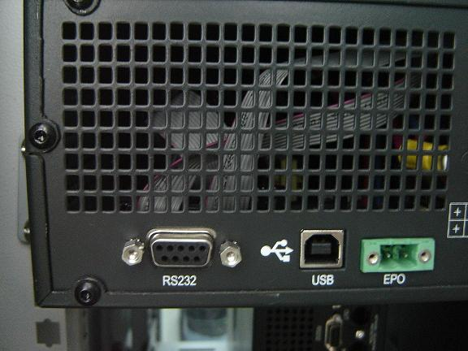
b, 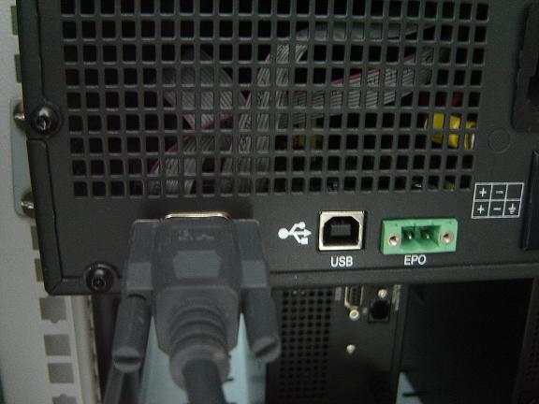
c, 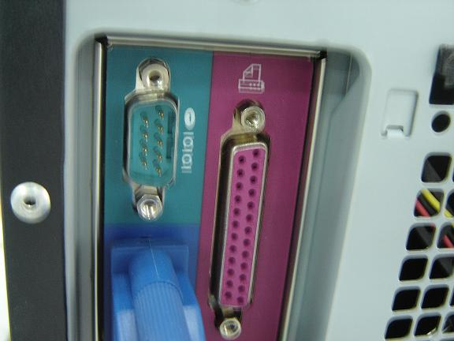
d, 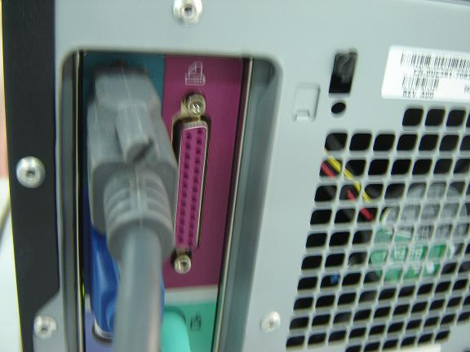

RS232 cable:
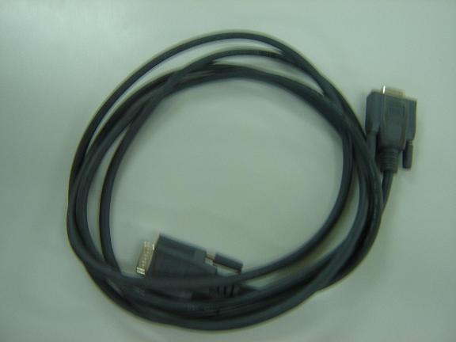

3, Connet UPS to main, and don’t turn on the UPS

4, RUN MGEFlash.exe (Path : start\ programme\ MGEFlash \MGEFlash.exe)
a,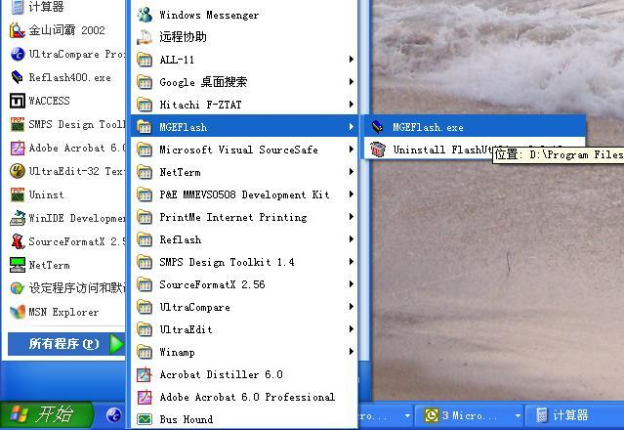
b, 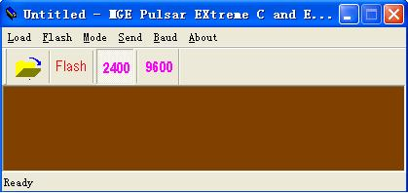
5, Click the button  to load the UPS firmware 120101s1Enable.mot
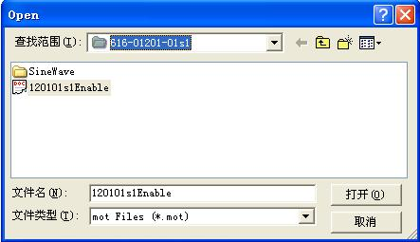
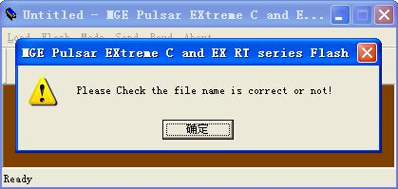
Please click the button

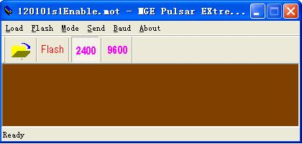
6, Click the button 
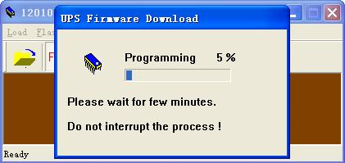
Please wait for few minutes, and don’t interrupt the process until it finish
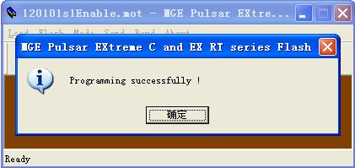
Programming successfully!
Please click the button ,
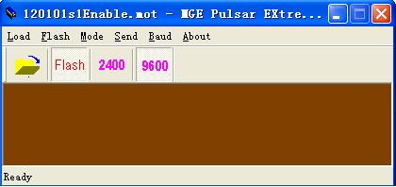
Pull out the RS232 cable from the UPS, and plug in RS232 cable to the next UPS(if more than 1 UPS proceed following step)
Click the button  (always select baud rate 2400)
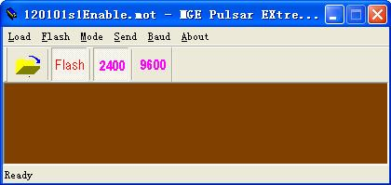
Click the button , then go to step 6

Close the promgram software MGEFlash.exe if no any other UPS need to Reprogram, pull out the RS232 cable from UPS and PC.

