- In Windows operating system
- Start Agent: Run the Winpower form Start\Progrom\Winpower will start the Tray Icon and Agent.
Refer to the Diagram below：
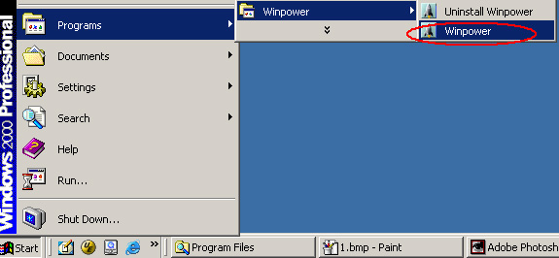
Diagram 1-1
- Right click the Agent icon showing on the bottom right corner of the display and select the ‘Start Agent’ item. Refer to Diagram 1-2.
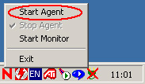
Diagram 1-2
- For Windows operate system, Agent can be startup automatically when the computer startup. In case of the monitor does not start up, please right click the Tray Icon and select the "Start Monitor" menu item. Refer to Diagram 1-3.
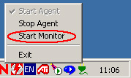
Diagram 1-3
- ”Winpower Manage" window
Winpower Monitor shows "Winpower Manager" window which display a list of all Agents within the LAN.
There is a tree view on the left side of the window that displays a hierarchical list of items, such as ‘Root’, ‘networks’, the Agents, the COM port, USB port and the UPS models. By clicking an item, the user can expand or collapse the associated list of sub items, Refer to the following diagram 2-1:
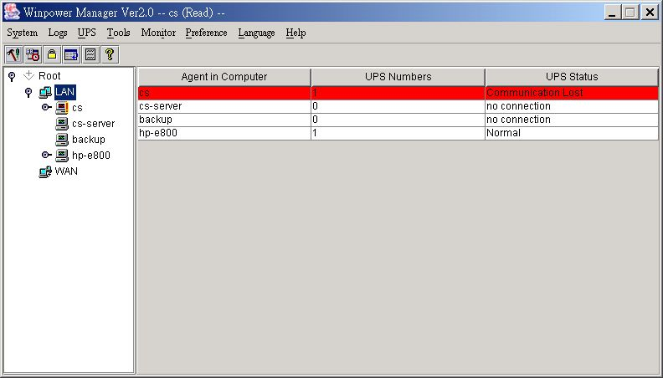
Diagram 2-1
- “Administrator” Dialog
"Administrator" dialog can be opened by clicking “Act as Administrator” in the “System” menu. See the following diagram 3-1. Enter the administrator password in the edit box and then click “OK” button. If the password is not correct, the system will pop up a message dialog to prompt users that the user password is not correct. If the password is correct, users can get the administrator access right and set up the Agent.
Note: Initial password is “Administrator”.

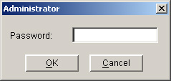
Diagram 3-1
- Auto Search UPS
When user select “Auto Search UPS " menu item from "System" Menu, Winpower will start searching for the UPS connect with the computer’s serial port. See the following diagrams 4-1 and 4-2.
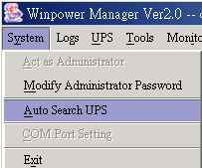
Diagram 4-1
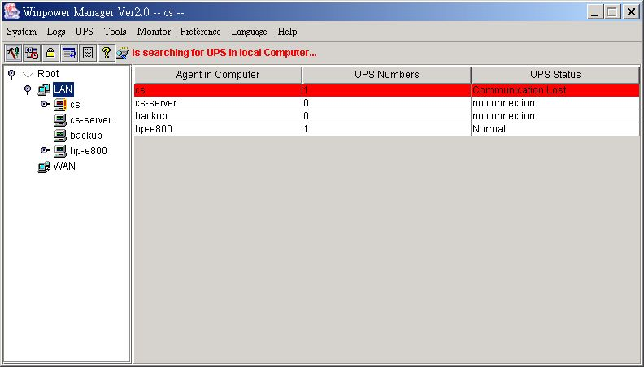
Diagram 4-2
- "UPS Control Parameters" Dialog
"UPS Control Parameters" Dialog will pop up when user select "UPS Control Parameters" item from “UPS” menu.
For Line-Interactive UPS, refer to the following diagram 5 -1:
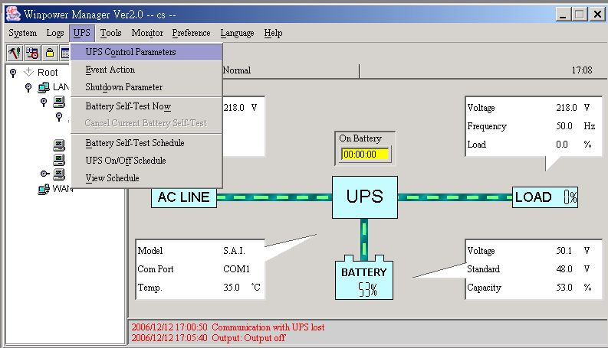
Diagram 5-1
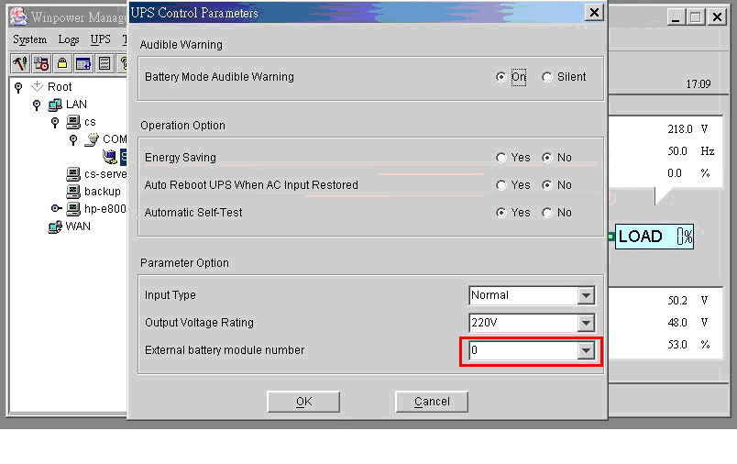
Diagram 5-2

※ See the following table for detail setting information.
Parameter | Unit | Maximum | Minimum | Default
Do audible warning when on battery mode | - | - | - | Yes
Energy Saving function |  |  |  | Yes
Restore line mode when AC restored | - | - | - | Yes
Automatic Self-Test | - | - | - | Yes

