4. INSTALLATION

- Rack-Mount Setup
750/1000/1500/2000VA(optional) and 3000VA can be installed in 19” racks. And the UPS and external battery enclosure need 2U of valuable rack space. Use the following procedure to install UPS in a rack.
Rack-Tray➔ Rack-Ear➔
SN | Color | Spec | Sketch Map
① | Gray | 483*260*77 | 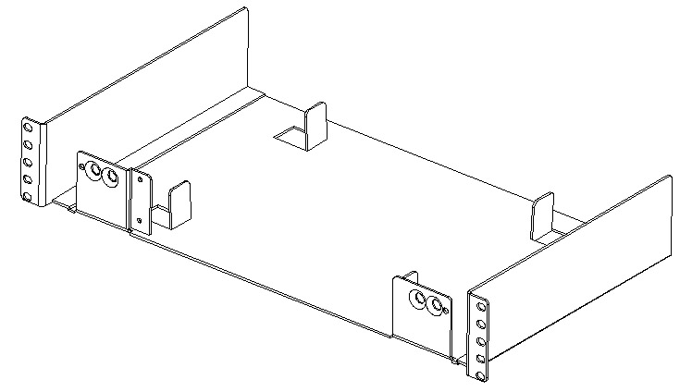
② | Gray | 75*23*16 | 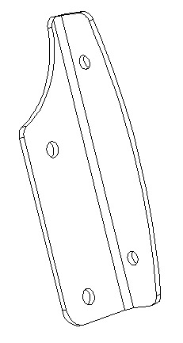
③ | Polychrome | M3*12 | 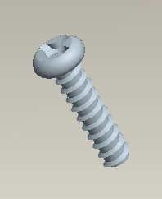
④ | nickel chrome steel | M4*8 | 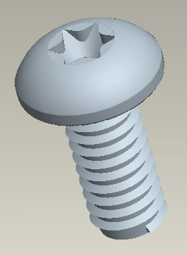
⑤ | nickel chrome steel | M6*16
⑥ | Black | 102*86*22 | 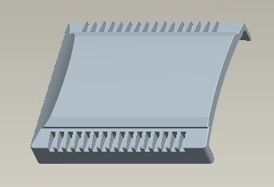

750/1000VA(optional)

1. Mount the ②(1ea) onto UPS with ③(2ea) as a UPS sub-assembly.

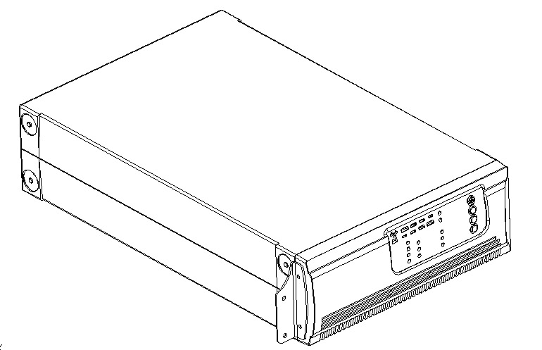

2. Lock UPS sub-assembly into ①(1ea) with ④(2ea) to get a UPS assembly.
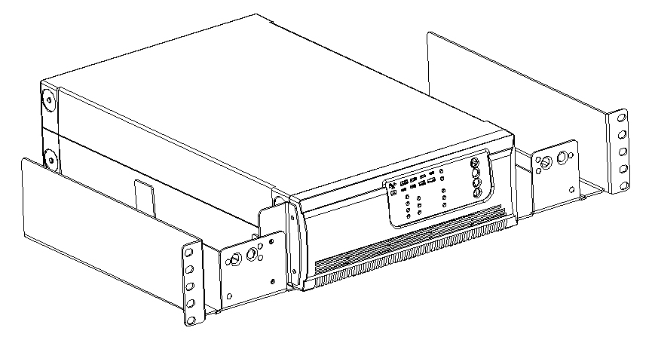
4. INSTALLATION

- Install UPS assembly with the ⑤(4ea or 6ea) provided tightened up into rack enclosure.
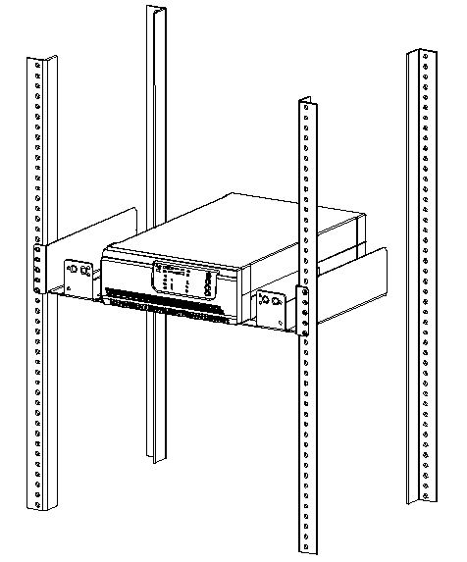

4. Add up ⑥(2ea) for both sides. The load can be connected.
