Rack-Mount Installation for JPX

750/1000/1500/2000VA(optional) and 3000VA can be installed in 19” racks. And the UPS and external battery enclosure need 2U of valuable rack space. Use the following procedure to install UPS in a rack.

750/1000VA(optional)

1. Align the mounting ears with screw holes on the side of the UPS.
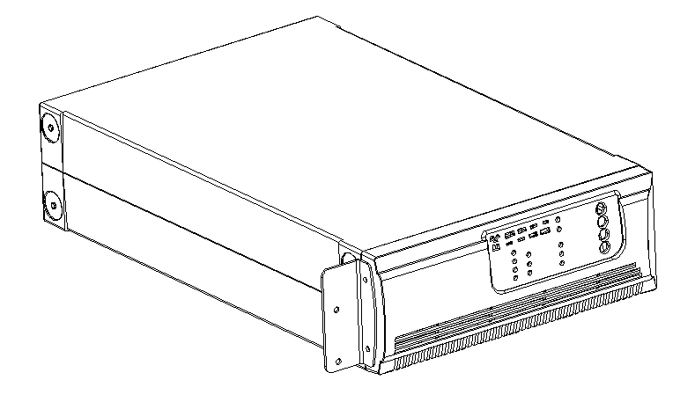

2. Install rack-mounting rails with the screws provided tightened up
into rack enclosure.
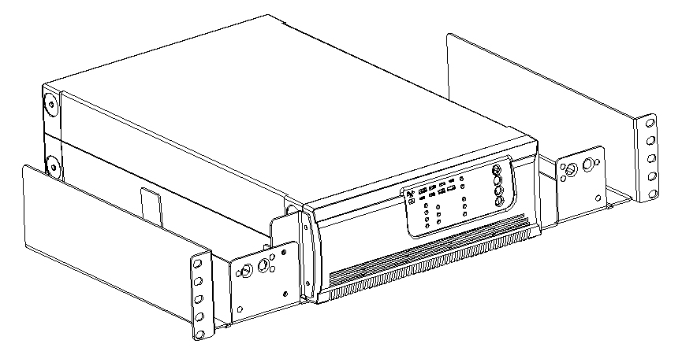

4. INSTALLATION

3. Insert UPS into the slide assemblies and lock it in the rack enclosure.
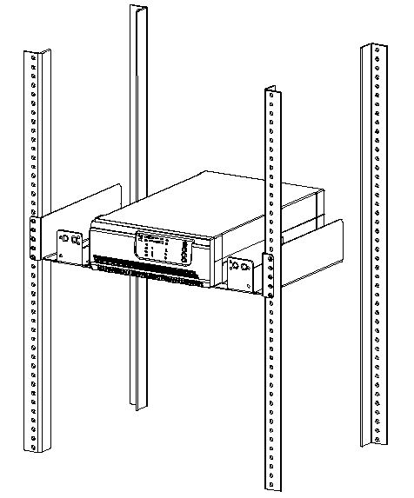

4. Add up the front panels for both sides. The load can be connected.
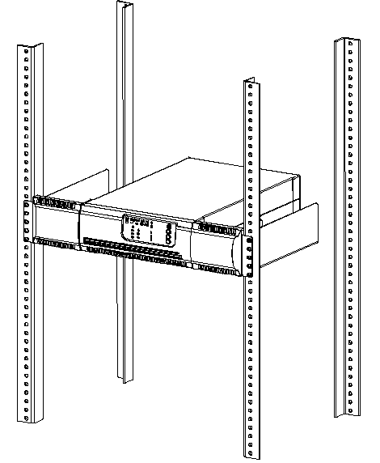
4. INSTALLATION

1500/2000VA(optional)

- HOST and EBM integrate into a rack form

- Place the UPS on a flat and in a clean place that the front side of the UPS is facing to you.

- Disconnect the cable from the Host and EBM.

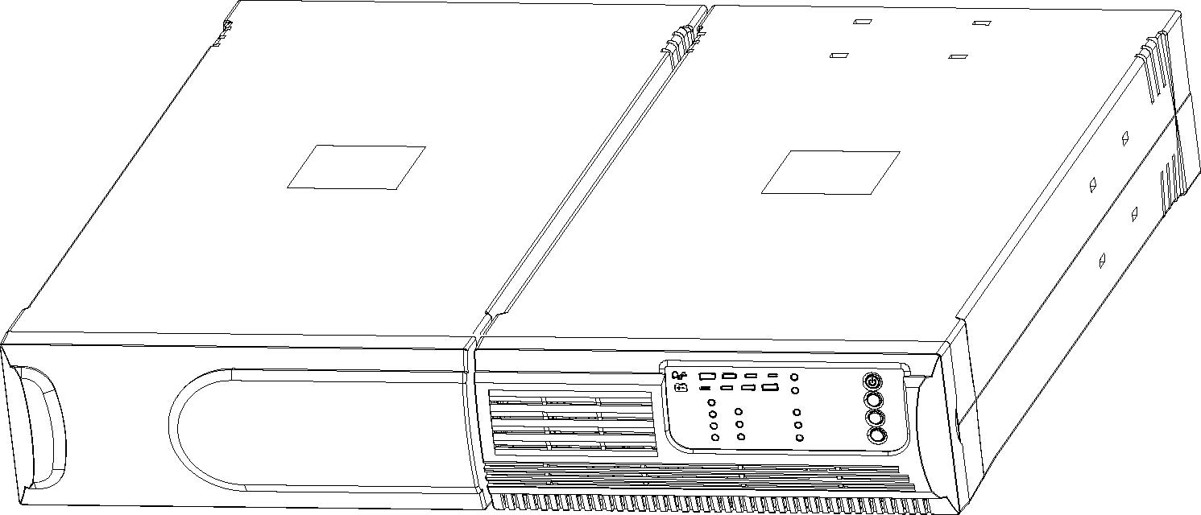

HOST and the EBM are disconnected

- Loosen the screws and remove the Host and EBM cover from the unit
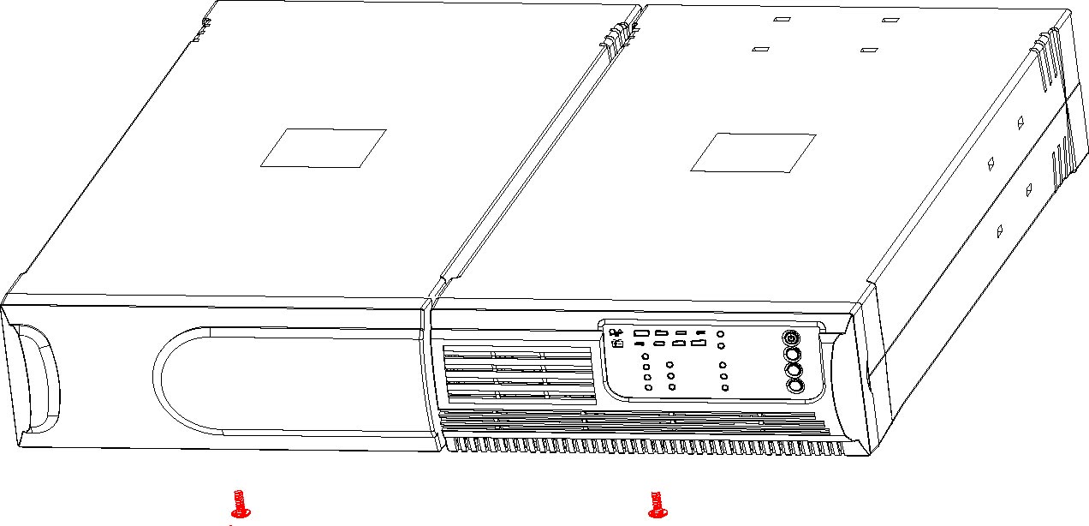

4. INSTALLATION

4. Pull two covers toward the direction shown as below.

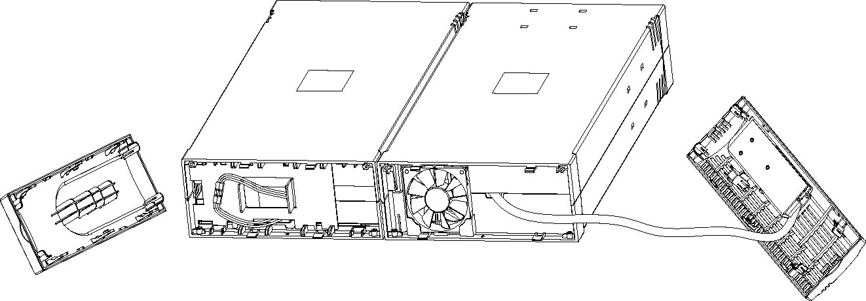

5. Align the mounting bracket with the screw holes on the each side of Host and EBM and secure with the supplied screws.
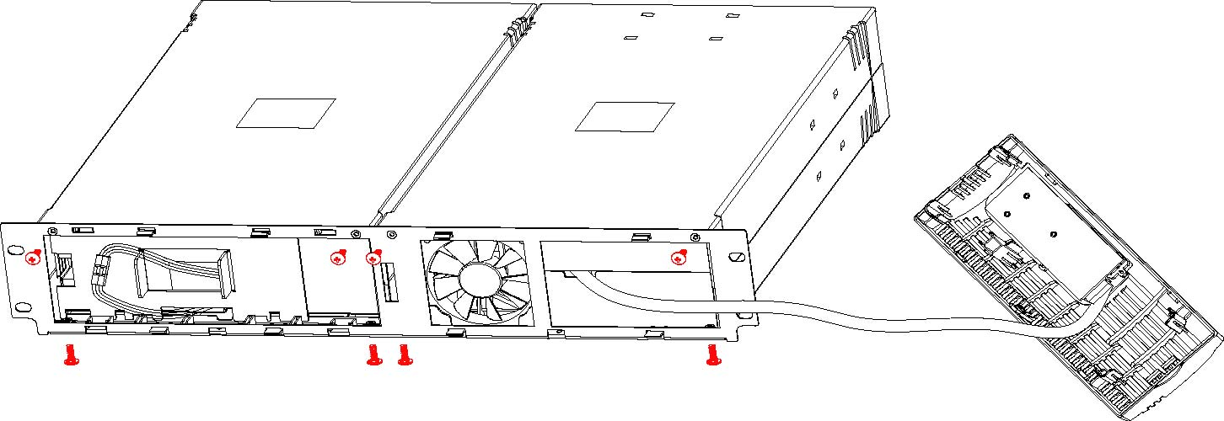

- Reinstall the Host and EBM cover.

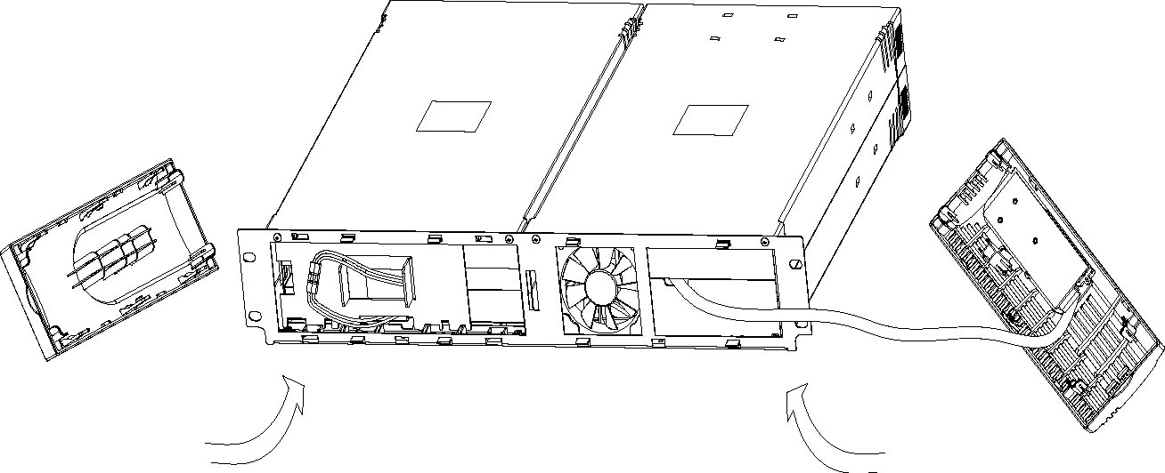

4. INSTALLATION

- Tighten all screws up to front panels and setup rack-mount for front
side is completed
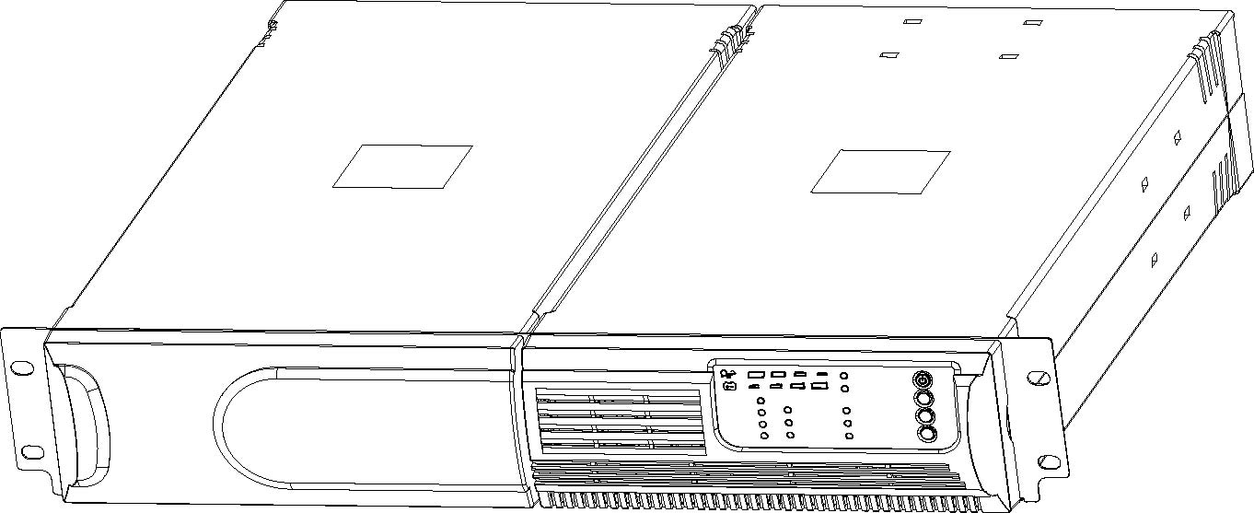

8. Align two small mounting brackets at the rear of Host and EBM and secure with the supplied screws. Install Output receptacles at the rear panel of the Host.
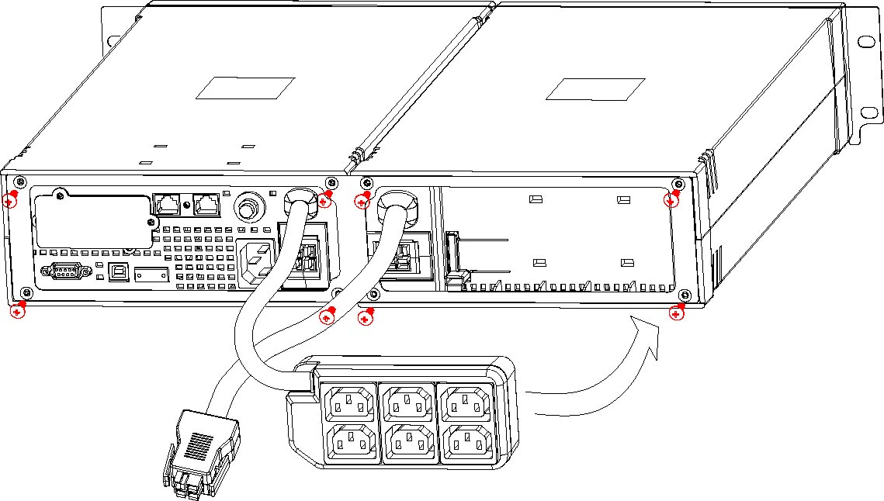

9. Setup rack-mount is completed and to connect the UPS

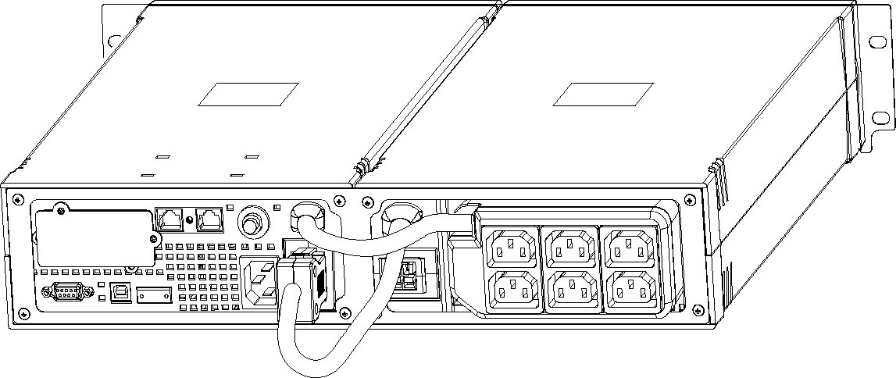

4. INSTALLATION

- EBM and EBM integrate a rack form
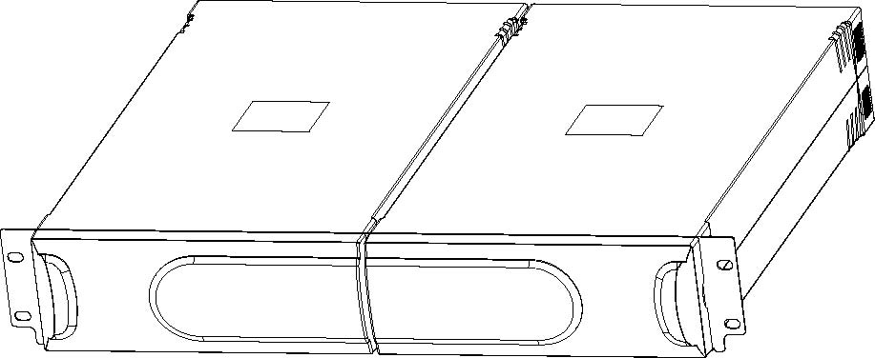

3000VA

Install the 3000VA series into 19” rack as shown below.
.
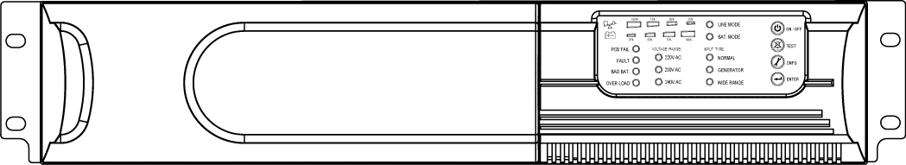

9. Turn on the UPS and connect the load.

10. After installing the UPS into rack, the load may be connected. Make
sure the load equipment is turned off, then plug all loads into the output receptacle properly protected by a circuit breaker of fuse in accordance with national and local electrical codes.

