Quick Installation and Setup for WinPower Software

- On the WinPower Installation menu, simply follow on-screen instructions and key in the software serial number. The installation will be automatically proceeded.
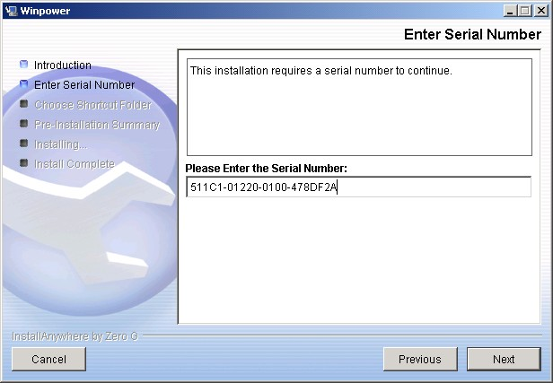
Enter the Right serial number here!!

- The software will start automatically after the Operation System is started. WinPower appears as a “Green Plug” icon in the right bottom corner of the TrayBar.
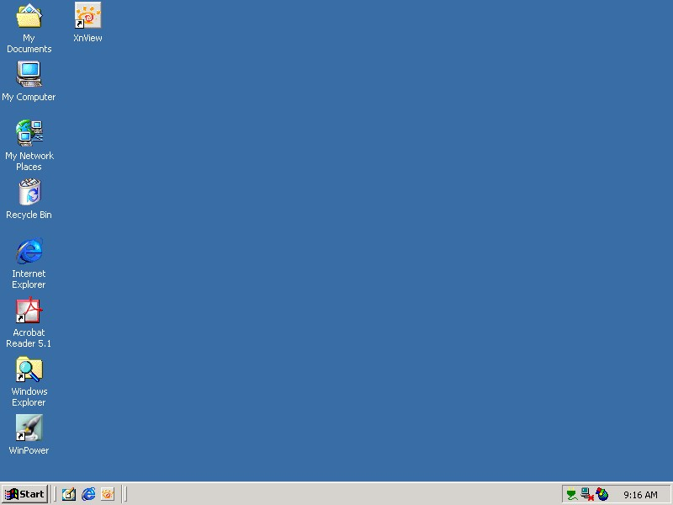
It means the WinPower is running now.
- If the WinPower is running and you execute the software again then you would see a message for “ Minimize” or “Exit”. The message is also shown as below. If you can see it then it means that you already execute the software twice.
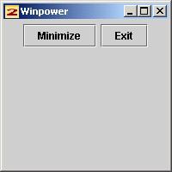

- After you start the system and the WinPower is also running in the Traybare, you have to use “ Right Click ” on the Green Plug then click on “ Start the Monitor “ to switch on the main screen of the software.
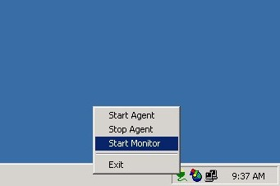
Right Click here then click on “ Start Monitor “

- After step D, you would see the screen is switching on as below message. After it runs to 100% you will see the main screen of the software.
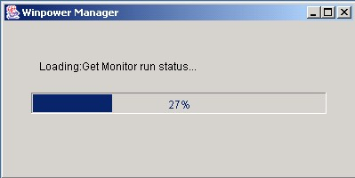

- Here is the main screen of the software. Before you login the software as an administrator, you will see a (Read) message on the title of the software. It means that you only can monitor the UPS and you cannot change any setting of the software or the UPS.
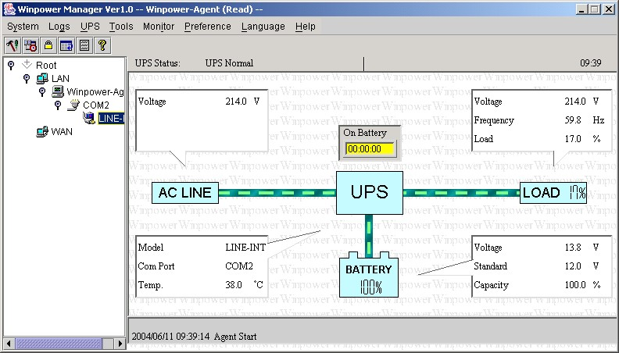

- To change settings, you need to log in WinPower as an administrator by going to “Act as Administrator” option of System section. The default password is Administrator.
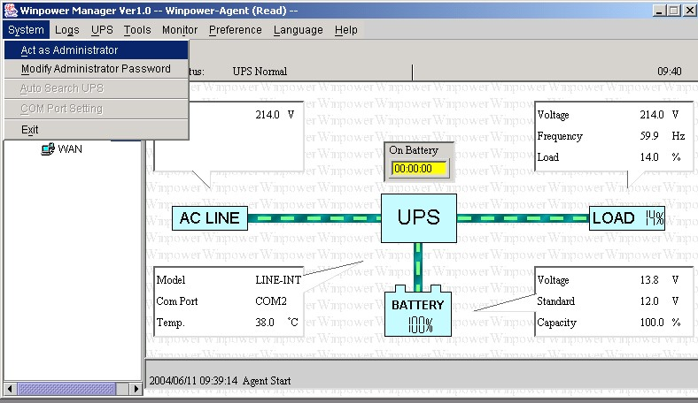

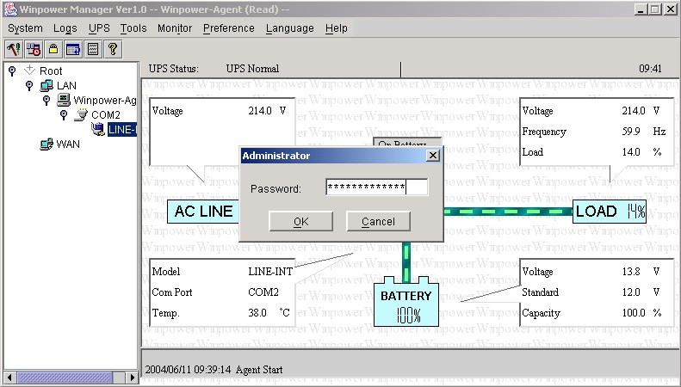
The default password is Administrator

- Now, you can find the information of (Read) is gone. Hence, you can go access other sheets of the software to have your own setting for the software and the UPS now.
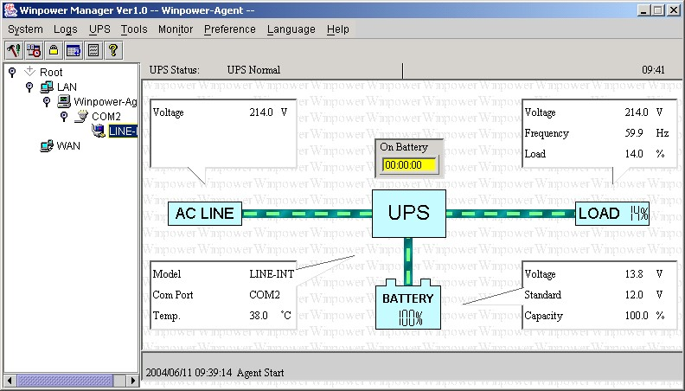

Function Explanation of “Shutdown Parameter”
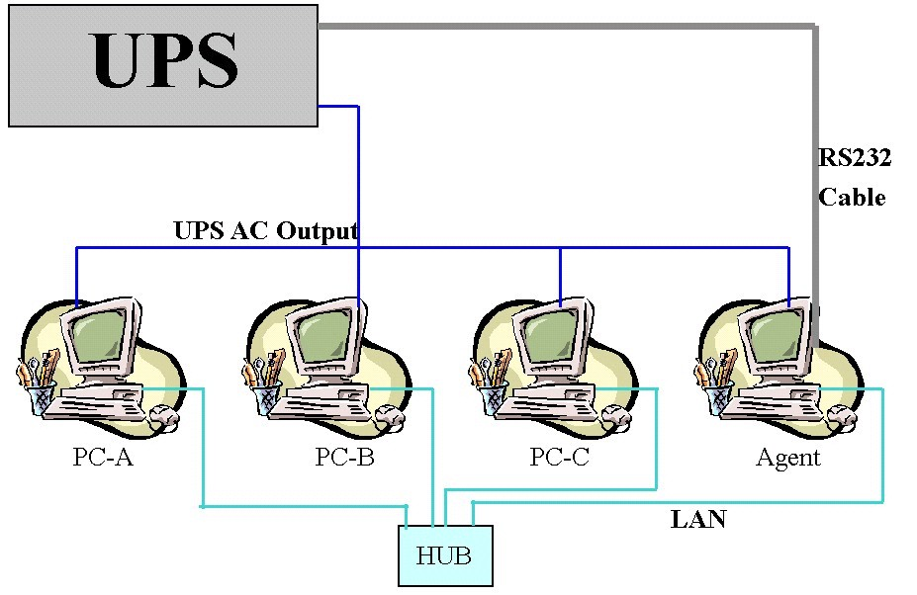
- To support the remote monitor/control function of WinPower, you need to have the similar connection as above. It means that the Agent is connected to the UPS via RS232/USB and the other Computers are protected via the AC Power only and all the computers are communicated under the same Network with LAN.
- All the computers need to install the WinPower software to keep them with the same interface for remote shutdown application. If you don’t install the WinPower on them then you would not able to do the remote monitor/control.
- Ignore the “ Communication lost” message in PC-A to PC-C. Owing to the fact that there is no RS232 cable connect to PC-A ~ PC-C. So you will see the message of “ Communication lost”. Moreover, you would find that these PC is without the in the front of the PC listed in the WinPower monitor screen as below.
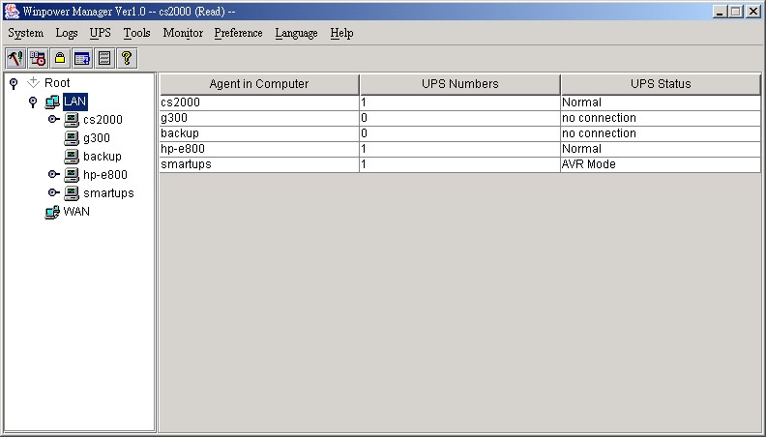
- If all the computers are communicated within the “same section of network”, the software will detect all the PC which is installed the WinPower and show them in the left window of WinPower as above photo for cs2000, g300, backup, hp-e800 & smartups automatically.
Notes: “Same section of network” means the three front numbers of its IP address is the same just like 192.168.1.XXX.
- If the IP address is out of the same section of the Agent, you have to key-in the IP manually for doing the remote monitor/control via “Monitor”->”Monitor Remote UPS”
- There are two major parts of the sheet of “Shutdown Parameter” in the WinPower as below.
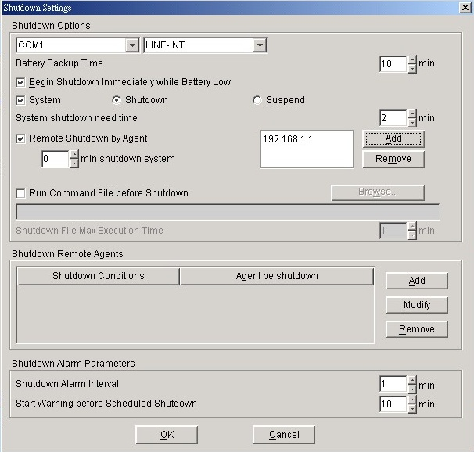
This part is used for the local Agent only.
This part is used for the remote PC
- There are three items will effect the UPS backup time of the local Agent as below.

A. Battery Backup Time (AA minutes)
B. Begin shutdown immediately while battery low
C. System shutdown need time (CC minutes)

7-1. In normal status, when the backup time reaches the value of AA minutes, the WinPower would send the command to shutdown the PC. After the CC minutes, the UPS would also shutdown automatically. It means the UPS will work in battery mode for AA+CC minutes.

7-2. If you enable the function of item B, once the UPS transfer to battery mode for XX minutes (XX<AA) and the UPS start to inform the low battery warning. Then the WinPower would send the command to shutdown the PC. After CC minutes, the UPS would also shutdown automatically. It means the UPS will transfer to battery mode for XX+CC minutes.

7-3. If you disable the function of item B, once the UPS transfer to battery mode for XX minutes (XX<AA) and the UPS start to inform the low battery warning. The UPS would still keep working till AA minutes. If the UPS could not support the load till AA minutes, the UPS and the load (PC) would shutdown directly when the battery is empty. If the UPS could support the load till AA minutes, when the backup time reaches the value of AA minutes, the WinPower would send the command to shutdown the PC. After the CC minutes, the UPS would also shutdown automatically. It means the UPS will transfer to battery mode for AA+CC minutes.

- There are also two main functions on the operation of the “Shutdown Remote Agent” as below.
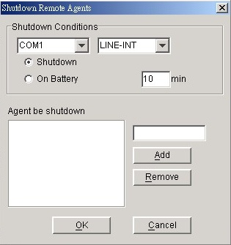
The item of “Shutdown” means that when the UPS of the Agent is going to shutdown, the WinPower will send out the shutdown command to the remote PC of the IP that you added in the below space.

The item of “On Battery” means that when the UPS of the Agent transfer to battery for XX minutes, the WinPower will send out the shutdown command to the remote PC of the IP that you added in the below space.
Hence, you only can change the time setting when you select this item.
9.Below setting is on the Agent.
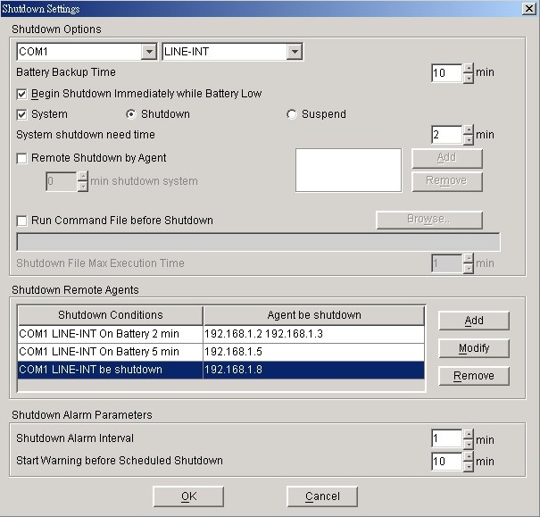
9-1. Refer to the left setting, it means that the backup time of the UPS in COM1 is 10 minutes.

9-2. When the UPS of the Agent transfer to battery mode for 2 minutes, the Agent will send out the shutdown command to 192.168.1.2 & 192.168.1.3.

9-3. When the UPS of the Agent transfer to battery mode for 5 minutes, the Agent will send out the shutdown command to 192.168.1.5
9-4 When the UPS of the Agent is going to shutdown (10 minutes on this sample), the Agent will send out the shutdown command to 192.168.1.8

- In Remote sides (PC-A, PC-B…), You have to enable the icon of “ Remote Shutdown by Agent” at first. Click “Add” button in the ”Shutdown Options”, enter IP address of the Agent in the pop up dialog. Press the “OK” button to finish the setting. After this, When the local Agent received the specified agent's shutdown signal, system can be shutdown in delay time. If you don’t enter the IP address of the Agent, the remote PC would not implement the shutdown procedure after it receives the shutdown command from the Agent.

